**COMSATS University Islamabad, Lahore Campus**

## 

## Microprocessor and Assembly

# Mid Term – Lab Exam

* **Submitted By:** M. Maiz Nadeem
* **Registration Number:** SP21-BCS-052
* **Session:** BCS – B (FALL 2022)
* **Date:** 24th Nov, 2022
* **Submitted To:** Sir Amaid Zia

# Question no 1

## Code:

|  |  |
| --- | --- |
|  | ORG 100H |
|  |  |
|  | .DATA |
|  |  |
|  | N       *DB*  0 |
|  | COLS    *DB*  0 |
|  | LEFT    *DB*  0 |
|  | RIGHT   *DB*  0 |
|  |  |
|  | .CODE |
|  |  |
|  | MOV AH, 1 |
|  | INT 21H |
|  | MOV COLS, AL |
|  |  |
|  | ADD COLS, AL |

## Output:

# Question no 2

## Part A:

## Code:

|  |  |
| --- | --- |
|  | ORG 100H |
|  |  |
|  | .DATA |
|  |  |
|  | DIFF    *DW*  ? |
|  | X       *DW*  7 |
|  | Y       *DW*  3 |
|  |  |
|  |  |
|  | .CODE |
|  | XOR CX, CX |
|  | MOV AX, X |
|  | MOV BX, Y |
|  |  |
|  | CMP AX, BX |
|  | JGE XGREAT |
|  | MOV DIFF, BX |
|  | JMP REMAINDER |
|  |  |
|  | XGREAT: MOV DIFF, AX |
|  | JMP REMAINDER |
|  |  |
|  | REMAINDER: XOR DX, DX |
|  | XOR AX, AX |
|  | MOV AX, DIFF |
|  | MOV CX, X |
|  | DIV CX |
|  |  |
|  | CMP DX, 0 |
|  | JNE NOTEQUAL |
|  |  |
|  | XOR DX, DX |
|  | XOR AX, AX |
|  | MOV AX, DIFF |
|  | MOV CX, Y |
|  | DIV CX |
|  | CMP DX, 0 |
|  | JE  EQUAL |
|  |  |
|  |  |
|  | NOTEQUAL: INC DIFF |
|  | JMP REMAINDER |

## Output:

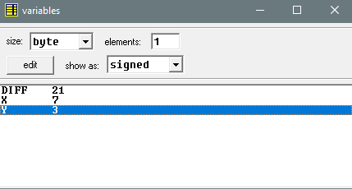

## Part B:

## Code:

|  |  |
| --- | --- |
|  | ORG 100H |
|  |  |
|  | .DATA |
|  |  |
|  | S   *DW*  0, 1, 2, 7 DUP (2) |
|  |  |
|  | .CODE |
|  |  |
|  | LEA SI, S |
|  | XOR BX, BX |
|  | ADD SI, 6 |
|  |  |
|  |  |
|  | LOOPARRAY: |
|  | INC BX |
|  | MOV DX, 0 |
|  |  |
|  | SUB SI, 2 |
|  | ADD DX, [SI] |
|  | SUB SI, 2 |
|  | ADD DX, [SI] |
|  | SUB SI, 2 |
|  | SUB DX, [SI] |
|  |  |
|  | ADD SI, 6 |
|  | MOV [SI], DX |
|  | ADD SI, 2 |
|  |  |
|  | CMP BX, 7 |
|  | JL LOOPARRAY |
|  |  |
|  |  |
|  | RET |

## Output:

